Good morning Aaron

Sandyford Business District invites you to join us on Thursday March 7th from 12.30 to 2pm to celebrate International Women’s Day 2024.
This event is free to attend but spaces are filling up quickly so please rsvp today.
The theme is Women Who Lead: Inspiring Voices
Hear from inspiring and innovative women in a number of leadership roles.
Our MC will be Lorraine Higgins, Founder and MD of Rockwood Public Affairs
The panel speakers are…
- Denise Harris, Chief Executive Officer at Harris Group
- Susanne Manning, Vice President Infrastructure Design Engineering at Mastercard
- Cllr Lettie McCarthy, Dún Laoghaire-Rathdown County Council
- Elaine Dunne, Regional And Sectoral Head of Business Banking Permanent TSB
Agenda:
12.30: Registration
12.45: Panel discussion followed by Q&A
1.30 – 2.00: Tea/Coffee and light lunch with an opportunity to network

Location:

Dynamic Events – 60 Holly Avenue Stillorgan Business Park. A94 X4P0

Kind Regards

Niamh

Niamh Egan
Head of Marketing

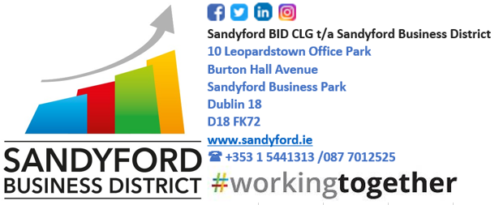

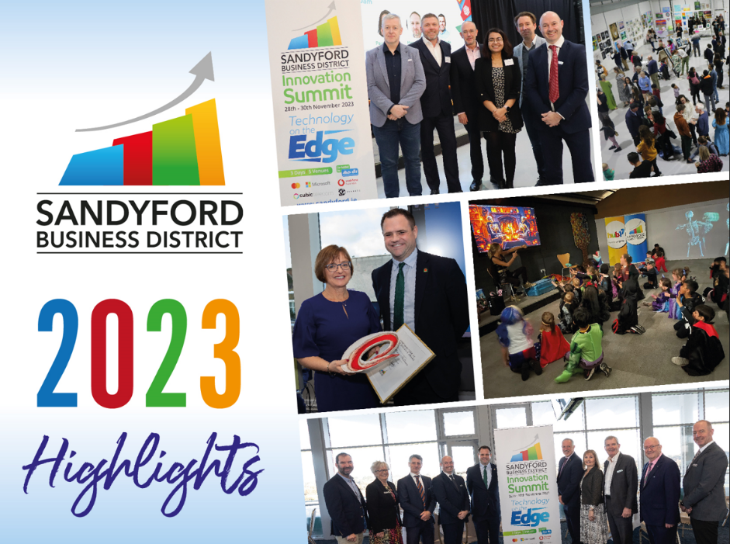

Join our mailing list and be the first to hear about local news, events, business supports and offers. https://www.sandyford.ie/subscribe

About Sandyford Business District
Sandyford Business District (SBID) is home to Mastercard, Microsoft, Vodafone, Bank of America Merrill Lynch, Facebook, Google, BNP Paribas and AIB among a host of other companies.
The Business Improvement District company, Sandyford BID CLG trading as Sandyford Business District, was established in January 2017 to represent the entire business community in the Sandyford Business District. It provides support for existing businesses within SBID and those looking to relocate and invest in the area. It has achieved considerable progress since its inception.
The business clusters in the Sandyford Business District include 118 Information and Communication companies; 99 MedTech companies; 63 Fintech companies; 8 Energytech companies; 27 Autotech companies; 17 Education and Childcare facilities; 49 Hospitality companies; and 117 Retail and Leisure companies.
SBD also represents the 5,000 (and growing) residents in the district.

